BNSI Critical Threshold Crossed alarm LLD
Version | Date | Author | Description
0.0 | 16th Nov 2011 | Chris Janes | Original

Description
This doc describes the updates to be made in the BNSI rules files for the Critical Threshold Crossed alarms generated by BNSI nodes.

HLD:
Multiple directories and files are created on BNSI at runtime. When any of these directories reach threshold an alarm is sent. When these alarms are received a TT should be raised with the classification of QOS alarm in the TT after 5 minutes.

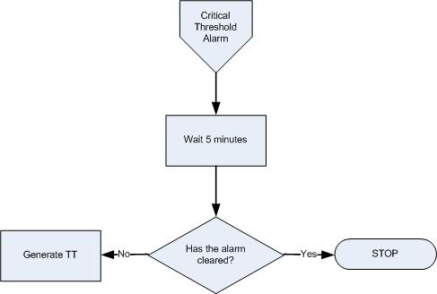

Critical Threshold Crossed alarm Handling Flow Chart

Pre-requisite
- Map added into TSRM between EventId “NET_IN_CTC_001” and classification “QOS ALARM”
- The TTHibernate field was added to the ObjectServer schema
- ML_RaiseTT_FirstOccurrence trigger was added in the ObjectServer

Event Filter:
No. | Alarm description | Domain | Field | Value | EventId
1 | BNSI Critical Threshold Crossed | BNSI | Summary | RtpAudMgr0x:Running out of file system or database space on /TspAccBackup: xx percent available  Matching condition:  regmatch(@Summary, ".*Running out of file system or database space on /TspAccBackup.* percent available") | NET_IN_CTC_001
2 | BNSI Critical Threshold Crossed | BNSI | Summary | RtpAudMgr0x:Running out of file system or database space on Global TspFt: xx percent available  Matching condition:  regmatch(@Summary, ".*Running out of file system or database space on Global TspFt.* percent available") | NET_IN_CTC_001
3 | BNSI Critical Threshold Crossed | BNSI | Summary | RtpAudMgr0x:Running out of file system or database space on /dump: xx percent available,  Matching condition:  regmatch(@Summary, ".*Running out of file system or database space on /dump.* percent available") | NET_IN_CTC_001
4 | BNSI Critical Threshold Crossed | BNSI | Summary | RtpAudMgr0x:File group oracleArchiveLog (path /export/home/oracle/dev/archivelog) too large, xyz MB now,  Matching condition:  regmatch(@Summary, ".*File group oracleArchiveLog .* too large") | NET_IN_CTC_001
5 | BNSI Critical Threshold Crossed | BNSI | Summary | OEM:inXXcey:Warning on Host inxxcey: -, /dev/vd/vdisk xxy (-), File System usage (XX) has exceeded the Warning level (YY),  Matching condition:  regmatch(@Summary, "OEM.*Warning on Host .* File System usage .* has exceeded the Warning level") | NET_IN_CTC_001
6 | BNSI Critical Threshold Crossed | BNSI | Summary | OEM:inxxcey:NOTICE: alloc: /global/[DIRECTORY NAME]: file system full,  Matching condition:  regmatch(@Summary, "OEM.* alloc.* file system full") | NET_IN_CTC_001
7 | BNSI Critical Threshold Crossed | BNSI | Summary | LogFileWriter: capacity 80 percent of file system partition /sxdata/apps/voms/logarchive  Matching condition:  regmatch(@Summary, "LogFileWriter: capacity .* percent of file system partition") | NET_IN_CTC_001
8 | BNSI Critical Threshold Crossed | BNSI | Summary | LoadService: Utilized capacity of tablespace VOMS_DATA11_HTMOVE2 of DB VOMS is >80 percent  Matching condition:  regmatch(@Summary, "LoadService: Utilized capacity of tablespace .* percent ") | NET_IN_CTC_001

Logic:

BNSI Critical Threshold Crossed alarm received
- Assign EventID, Domain and set TTHibernate=300 (seconds) for relevant network alarms as defined in event filter section.

If not cleared after TTHibernate time, raise a TT for the alarm.
- The ML_RaiseTT_FirstOccurrence trigger checks for TTHibernate>0, Severity>0 and CurrentTime-FirstOccurrence>=TTHibernate and sets the alarm for ticketing (@LogTicket=1).

Resolution of events
EventId | Resolution mechanism
NET_IN_CTC_001 | Clearance of the network event is managed by its resolution event.

